user 
posted imageuser posted 
imageuser posted 
image

user posted 
imageuser 
posted imageuser 
posted image

user 
posted imageuser posted 
imageuser posted 
image

user 
posted imageuser posted 
imageuser posted 
image

user 
posted imageuser 
posted imageuser 
posted imageuser 
posted image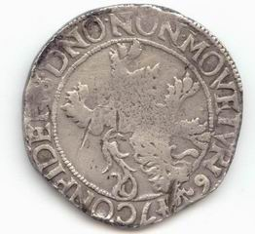

user 
posted image